Project 2 Report

Rod Izadi and Joseph Drahos

<https://github.com/JosephDrahos/Izadi-Drahos-CS242-Project>

The command line output for the “DONE” option in the ClackClient.readClientData() method is seen below.

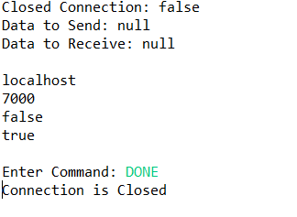

The command line output for the “SENDFILE” option in the ClackClient.readClientData() method is seen below.

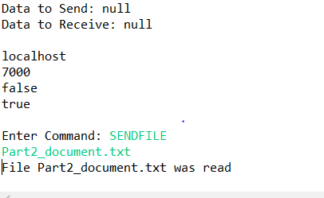

The command line output for the testClackfile.tostring() that prints the decrypted file contents is seen below. 